Beginner Linux Challenges

Task 6
- Please see figure 1
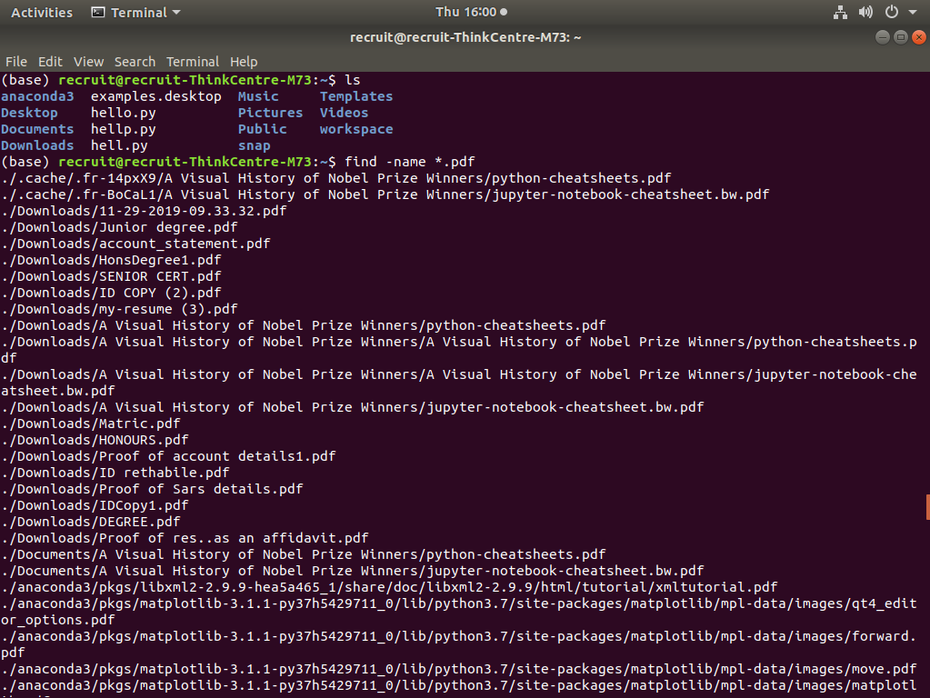
- Please see figure 2
figure 2

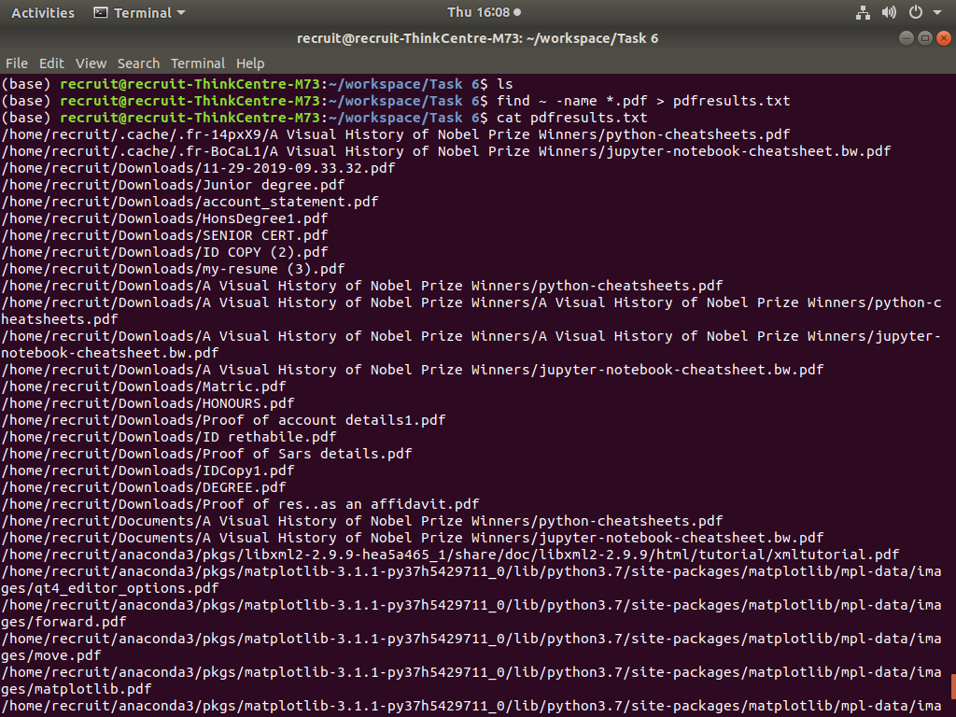
- Please see figure 3
figure 3
